CHAPTER 1: Slope

☐ **Day 1**  Pythagorean Theorem

☐ **Day 2** Proportion and Tangent Ratio

☐ **Day 3** Slope

☐ **Day 4** Grade, Pitch and Distance

☐ **Day 5** Angles of Elevation

☐ **Day 6** Cartesian Plane

☐ **Day 7** Rate of Change

☐ **Day 8** Water Park Assignment

☐ **Day 9** Chapter Review

☐ **Day 10** Chapter Test

|  |
| --- |
| ***Booklet Criteria*** |
| ***Assignments (2 marks each day)***   * *completed neatly* * *all work is shown* * *pencil and ruler used* * *marked in different colour ink*   ***Class Notes***   * *completed neatly* * *pencil and ruler used*   ***Details***   * *handed in on time* * *care taken and neat* * *used class time effectively*   ***Water Slide Assignment***  *Students found* ***copying*** *or* ***lending*** *their booklets will receive zero.* |

**DAY 1** *Pythagorean Theorem class notes*

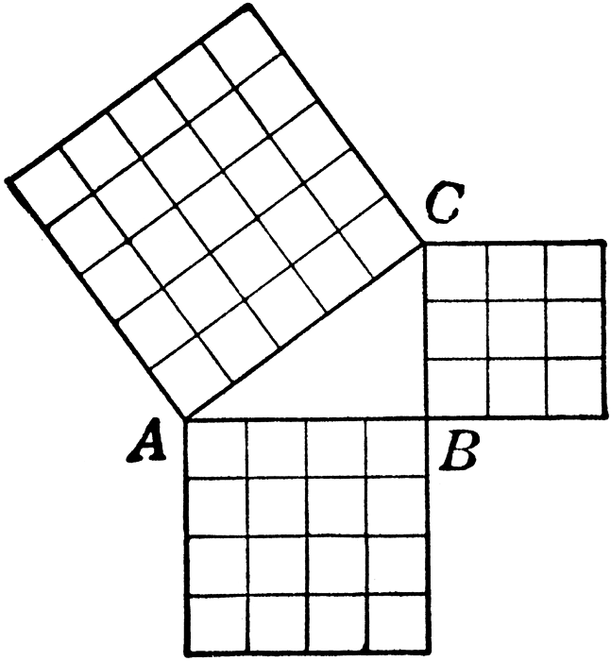**Right Triangle**

|  |
| --- |
|  |
|  |

**Pythagorean Relationship**

|  |
| --- |
|  |
|  |
|  |

HOW TO **Find the Hypotenuse of a Right Triangle**

|  |  |
| --- | --- |
|  | TA BLM3-15-4***Example:*** |
| *1. Identify the hypotenuse* |  |
| *2. Write Pythagorean Relationship* |  |
| *3. Insert the lengths of the triangle* |  |
| *4. Square the lengths* |  |
| *5. Add the squares* |  |
| *6. Find the square root* |  |
| *7. Write your answer* |  |

**DAY 1** *Pythagoras’ Theorem class notes*

**The Modified Pythagorean Relationship:**

HOW TO **Find the Leg of a Right Triangle**

|  |  |
| --- | --- |
|  | ***TA BLM3-15-5Example:*** |
| *1. Identify the hypotenuse* |  |
| *2. Write correct equation*  *(do you have a known hypotenuse?)* |  |
| *3. Sub in 2 length values…* |  |
| *4. Square the values…* |  |
| *5. Solve for the unknown square* |  |
| *6. Find the square root* |  |
| *7. Does your answer make sense??* |  |

**DAY 1** *PythagoreanTheorem assignment*

**Multiple Choice**

1. In order to use the Pythagorean theorem, what must be true about a given triangle?

a) The triangle must be a right triangle, with one angle being 90°.

b) The sum of the interior angles of the triangle must add to 180°.

c) The triangle must be an acute triangle, with one angle being 45°.

d) The triangle must be an obtuse triangle, with one angle being 135°.

1. Check for Pythagorean triples:

a) 9, 11, 17

b) 7, 24, 25

1. A carpet has side lengths of 3.2 m and 4.6 m. What is the distance between opposite corners of the carpet? Draw diagram, add hypotenuse, and solve.

a) 3.3 m c) 5.6 m

b) 2.8 m d) 7.9 m

1. TV screen sizes are indicated by the distance between opposite corners. A TV has sides that are 32 in high and 43 in wide. What is the size of the TV? Draw diagram and solve.

a) 29 in c) 59 in

b) 59 in d) 54 in

1. A park is 45 m long by 30 m wide. When travelling between opposite corners, how much shorter is it to walk diagonally across the park instead of walking along its sides?
2. Draw diagram.
3. How long traveling on the edges of the field (2 sides).
4. How far across the field? Find the diagonal.
5. Subtract to answer the question.

a) 26 m c) 51 m

b) 54 m d) 21 m

1. A ladder is 5 m long. If it is leaning against a wall, with the bottom of the ladder 1.5 m away from the base of the wall, how high up the wall will it reach? Draw and solve below.

a) 5.7 m c) 3.67 m

b) 5.22 m d) 4.77 m

1. Each side of a square is 10 cm long. What is the length of the diagonal of the square? Draw and solve.

a) 14.14 cm c) 17.14 cm

b) 18.54 cm d) 20.14 cm

1. A rectangle has a length of 12 cm and an area of 120 cm2. Work backwards from the area to find the missing side length. Find the length of the diagonal of the rectangle.

a) 17.62 cm c) 120.60 cm

b) 15.62 cm d) 119.40 cm

**Short Answer**

**Find the missing side of each right triangle. Show your calculations.**

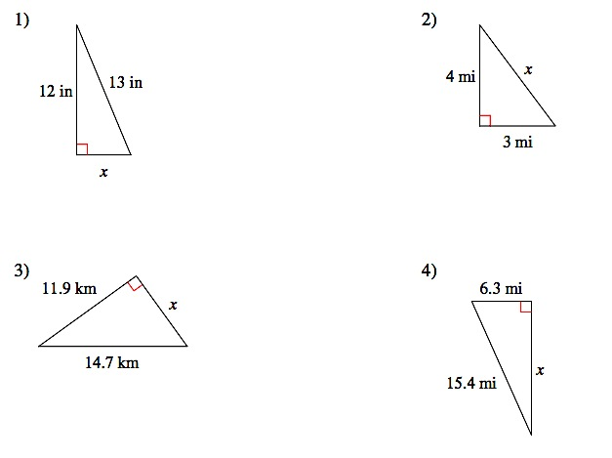

**DAY 2** *Proportion and Tangent Ratio class notes*

**Proportion**

|  |
| --- |
|  |
|  |

HOW TO **Solve a Proportion**

Recall from Math 10 AW that we can use “cross multiply and divide” to solve for any missing values…

Examples:

1. $\frac{10}{x}$ = $\frac{8}{4}$
2. $\frac{3}{2}$ = $\frac{m}{4}$
3. A store buys a box of bananas for $22.50. There are usually 50 bananas per box. What is the price per banana?
4. Mix gas to oil in a tank at a ratio of 50:1. How much oil if you pump in 127.5 L of gas?

**Tangent of an Angle**

|  |
| --- |
|  |
|  |

|  |  |  |  |
| --- | --- | --- | --- |
| tan 15**°** |  |  | tan A =  tan B = |
| tan 45**°** |  |
| tan 75**°** |  |

HOW TO Solve Triangles Using the Tangent Ratio

***Example 1:* Finding the Adjacent Side**

How far is the kayaker from the base of the cliff?

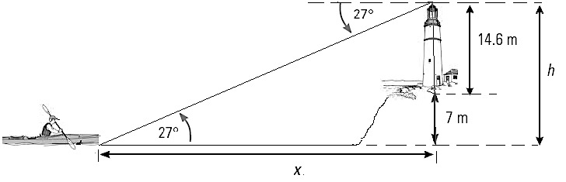

***Example 2:* Finding the Opposite Side**

What is the length of the chain that is lifting the cargo?

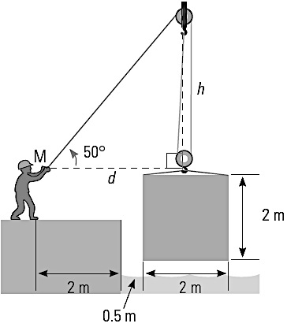

***Example 3:* Finding the Angle**

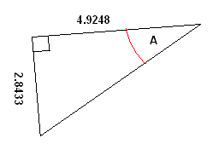

**DAY 2** *Proportion and Tangent Ratio assignment*

Read problem. Write the known ratio. Set it equal to the new ratio, containing the unknown. Remember to match top and bottom units across the proportion. Use cross-multiplication to solve.

1. Shawna reduced the size of a rectangle to a height of 2 in. What is the new width if it was originally 24 in wide and 12 in tall?
2. Ming was planning a trip to Western Samoa. Before going, she did some research and learned that the exchange rate is 6 Tala for $2. How many Tala would she get if she exchanged $6?
3. If you can buy 32 kiwi fruit for $16, how many kiwi can you buy for $4?
4. One bunch of seedless black grapes costs $2. How many bunches can you buy for $20?
5. Alex’s dirt bike requires 15 L of gas to be mixed with 4 L of oil. If he uses 20 L of gas, how much oil will he need? Round to the nearest tenth of litre.
6. In a juice mixture, 750 mL of water are mixed with 250 mL of juice concentrate. What is the ratio of **concentrate to water**? Put ratio in lowest terms.
7. A recipe for corn chowder includes 3 cups of corn, 2 cups of water, and one and a half cups of cream. If one increases the yield of the recipe and uses four and a half cups of cream, **how much corn** will be required?
8. If cereal mixture contains 6 cups of oats, 2 cups of almonds, 1 cup of raisins, and three quarters of a cup of coconut.
9. What is the ratio of almonds to coconut?
10. What is the ratio of oats to raisins?
11. What is the ratio of oats to the **total ingredients in the recipe**?
12. Find the length of the indicated side of the triangles. Show your work!

a.

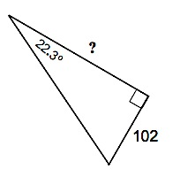

b.

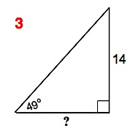

?

14 m

c.

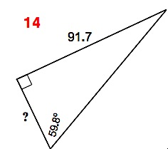

d.

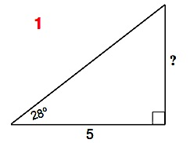

1. Find the missing two angles of the given triangle. (Hint: Use tangent to find one of the angles. You can use angle sum in a triangle of 180˚ to find the 3rd angle.)

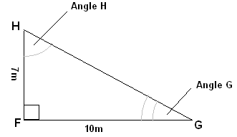

**DAY 3** *Slope class notes*

**Rise**

|  |
| --- |
|  |
|  |

**Run**

|  |
| --- |
|  |
|  |

**Slope**

|  |  |
| --- | --- |
|  |  |
|  |
|  |

EXAMPLE 1 **Completing a Slope Table**

|  |  |  |  |
| --- | --- | --- | --- |
| **Rise** | **Run** | **Slope (“m’’)** | |
| **Fraction** | **Decimal** |
| 5 ft | 20 ft |  |  |
| 10 cm |  |  | 0.25 |
|  | 24 in | $$\frac{32}{5}$$ |  |
| 21.5 ft |  |  | 0.75 |

EXAMPLE 2

Topographical maps showing elevation of land (how high above the sea level areas are) use contour lines joining points of equal elevation.

In this contour map the contour lines indicate height above sea level in meters. The distance on the map scale between points A and B is 2000 m. If a hiker is at point B heading for point A, what is the average slope she is to encounter?

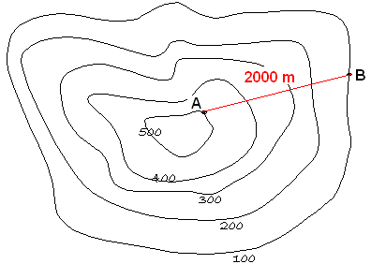

EXAMPLE 3

The side view of a shed is shown in the next drawing. The slanted iron roofing measures 5 m and the lowest point is 3 m lower than the highest point.

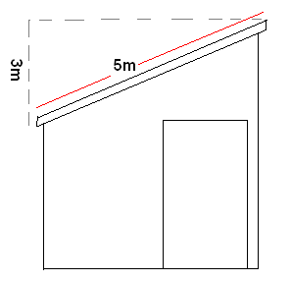

What is the slope of the roof? State as a fraction and decimal value.

If the roof is 8 m long (recall, its width is 5 m) and the iron roofing costs $6.50/m2, how much will the iron roofing cost?

**DAY 3** *Slope assignment*

1. Calculate the slope as a fraction in the simplest form and as a decimal. Round decimals to the tenth.

|  |  |  |  |
| --- | --- | --- | --- |
| **Rise** | **Run** | **Slope** | |
| **As a fraction** | **As a decimal** |
| 18 m | 63 m |  |  |
| 21 m | 49 m |  |  |
| 1.2 cm | 0.6 cm |  |  |
| 300 ft | 900 ft |  |  |

1. Use the information given to complete the table. Show your proportion below.

|  |  |  |
| --- | --- | --- |
| **Rise** | **Run** | **Slope** |
| 15 ft |  | $$\frac{1}{4}$$ |
| 12 cm |  | 0.375 |
|  | 42 in | $$\frac{32}{7}$$ |
| 63 m |  | 3.0 |
| 19.5 ft |  | 0.25 |

1. A ski jump rises 3 feet over a run of 7 feet.

Note that key gives answers in decimals only. Show the fractional slope, then change to decimal.

1. What is the slope of the ski jump?
2. What is the length of the surface of the jump?
3. Calculate the *marked angle* and the *slope* of the hypotenuse for each triangle.

a. b.

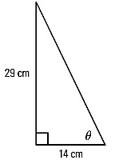 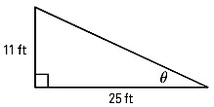

1. A driveway rises 2.2 m from the street level to the carport, which is a horizontal distance of 5.8 m from the street.
2. How long is the driveway? (Driveway length is the hypotenuse. Draw triangle!)
3. What is the angle between the driveway and the horizontal? Write trig equation, and solve for unknown angle.
4. One of the steepest railways in the world is the Lisbon tram in Portugal. In one section, it has a slope of 0.135.
5. Express this slope as a fraction.
6. Calculate the angle between the railway and the horizontal.
7. What is the rise for a run of 15 m? Draw again! Use angle from (b) and a trig equation.
8. So that water will drain properly, a patio attached to a house should drop downward about two and a half inches for every 10 feet of run. Calculate the slope. (12 inches = 1 foot) Draw! *Change all values to inches*.
9. Heckman Pass is a very steep section of highway connecting Anahim Lake and Bella Coola, BC. At its steepest section, it rises 900 m over a run of 5 km. What is the **slope** of this section? (1000 m = 1 km) Draw! *Change everything to metres.*
10. What is the pitch of the roof of an A-frame building if its height is 3.6 m and its width is 5.4 m? (Consider only one side of the roof.)

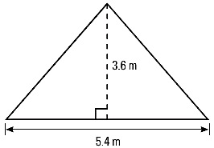

**DAY 4** *Grade, Pitch and Distance class notes*

**Grade**

|  |
| --- |
|  |

|  |
| --- |
| Percent Grade = $\frac{rise}{run}$ x 100 |

EXAMPLE 1

Martin is driving his truck on the Trans-Canada Highway. There is a sign indicating a 7% grade. What is the slope of the road, as a fraction?

**Pitch**

|  |
| --- |
|  |

EXAMPLE 2

The roof of a tool shed has a pitch of 2:5. If the shed is 7 feet wide, what is the rise of the roof?

**DAY 4** *Grade, Pitch and Distance class notes continued*

EXAMPLE 3

A wheelchair ramp is being built to rise to a landing that is 2.4 m above the ground. Building regulations say that the ramp can have a maximum rise of 2.5 cm per 20 cm of run.

1. What is the total run for the wheelchair ramp?
2. How long will the ramp be?

**DAY 4** *Grade, Pitch and Distance assignment*

1. Cole is driving his truck on the Trans-Canada Highway. There is a sign indicating a 9% grade.
2. What is the slope of the road, as a fraction?
3. A certain section of railroad track rises 6.8 metres for a run of 125.9 metres.
4. How long is the section of railroad track?
5. What is the percent grade of the road?
6. A ski jump is being built to be 3.5 m high. Olympic regulations state that the ramp must have a rise of 4.5 cm per 15 cm of run.
7. What is the total run for the ski jump?

1. How long will the ski jump be?
2. Heckman Pass is a very steep section of highway connecting Anahim Lake and Bella Coola, BC. At its steepest section, it rises 900 m over a run of 5 km. What is the percent grade of this section? *Change all units to metres before starting.*
3. So that water will drain properly, a patio attached to a house should slope downwards about 2.5 inches for every 10 feet of run. Calculate:
4. slope
5. percent grade.
6. One of the steepest railways in the world is the Lisbon tram in Portugal. In one section, it has a grade of 13.5%.
7. Express this as a slope.
8. Calculate the angle of elevation.
9. What is the rise for a run of 20 m?
10. Aurena is installing a pipe for drainage. The system requires a drop of 1.5 cm for every 2.5 m of horizontal distance.
11. What is the slope of the pipe?
12. How much drop will she need if the horizontal distance of 12 m?
13. A roof rises 2 feet for every 5 feet of run. What is the pitch of the roof?
14. The roof of one house has a pitch of 4.2 to 12. The roof of a second house has a pitch of 7.8 to 20. Which roof is steeper?
15. One straight section of road rises from an elevation of 1070 m to 1132 m. The run is approximately 1.3 km. What is the percent grade of the road?

**DAY 5** *Angle of Elevation class notes*

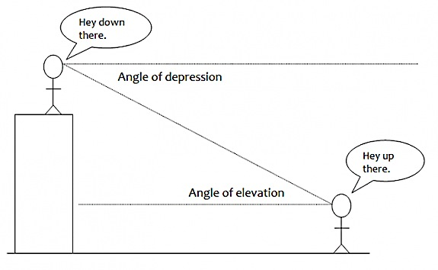**Angle of Elevation**

|  |
| --- |
|  |
|  |
|  |

**Angle of Depression**

|  |
| --- |
|  |
|  |
|  |

EXAMPLE 1

A skateboard ramp runs 5 feet and has an angle of elevation of 20**°**. What is the height of the ramp?

EXAMPLE 2

An airplane is flying at a [height](javascript:def('/Glossary/glossaryterm.aspx?word=Height',%20500,%20500);) of 2 miles above the ground. The distance along the ground from the airplane to the airport is 5 miles. What is the angle of depression from the airplane to the airport?

**DAY 5** *Angle of Elevation assignment*

1. John wants to measure the [height](javascript:def('/Glossary/glossaryterm.aspx?word=Height',%20500,%20500);) of a tree. He walks exactly 100 feet from the base of the tree and looks up. The [angle](javascript:def('/Glossary/glossaryterm.aspx?word=Angle',%20500,%20500);) from the ground to the top of the tree is 330. How tall is the tree?
2. A building is 50 feet high. At a distance away from the building, an observer notices that the [angle of elevation](javascript:def('/Glossary/glossaryterm.aspx?word=Angle%20of%20Elevation',%20500,%20500);) to the top of the building is 41º. How far is the observer from the [base](javascript:def('/Glossary/glossaryterm.aspx?word=Base',%20500,%20500);) of the building?
3. An airplane is flying at a [height](javascript:def('/Glossary/glossaryterm.aspx?word=Height',%20500,%20500);) of 3 miles above the ground. The distance along the ground from the airplane to the airport is 8 miles. What is the [angle of depression](javascript:def('/Glossary/glossaryterm.aspx?word=Angle%20of%20Depression',%20500,%20500);) from the airplane to the airport?
4. A campsite is 9.41 miles from a point directly below the mountaintop. If the angle of elevation is 12 degrees from the camp to the top of the mountain, how high is the mountain?
5. At a point 42.3 feet from the base of a building, the angle of elevation of the top is 750. How tall is the building?
6. How far from the door must a ramp begin in order to rise 3 feet with an 80 angle of elevation?
7. An A-frame cabin is 26 feet high at the center and the angle the wall makes with the base is 530. How wide is the base?
8. A building casts a shadow of 110 feet. If the angle of elevation from that point to the top of the building is 290, find the height of the building.
9. A building is 41.29 ft tall. The shadow cast by the building is 46.83 ft. Find the angle of elevation of the sun.
10. Joanna knows that when she stands 134 ft from the base of a flagpole, the angle of elevation to the top of the flagpole is 270. If her eyes are 5.4 ft from the ground, find the height of the flagpole.

**DAY 6** *Cartesian Plane class notes*

**Cartesian Plane**

|  |
| --- |
|  |
|  |

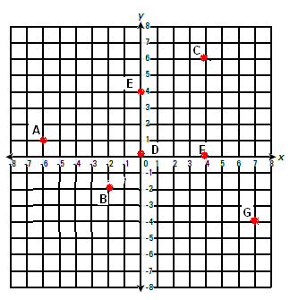

**Coordinate Points**

|  |
| --- |
| A = |
| B = |
| C = |
| D = |
| E = |
| F = |
| G = |

HOW TO Calculate Slope on a Cartesian Plane

1. Find two points with exact coordinates
2. Use the slope formula

SLOPE FORMULA: m = $\frac{y2-y1}{x2-x1}$

EXAMPLE 1

Find the slope of the line below

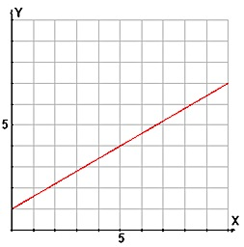

The slope of a line can be…

|  |  |
| --- | --- |
| a.  Macintosh HD:Users:beckysulek:Desktop:Screen shot 2012-02-25 at 3.55.39 PM.png | b.  Macintosh HD:Users:beckysulek:Desktop:Screen shot 2012-02-25 at 3.55.39 PM.png |
| c.  Macintosh HD:Users:beckysulek:Desktop:Screen shot 2012-02-25 at 3.55.39 PM.png | d.  Macintosh HD:Users:beckysulek:Desktop:Screen shot 2012-02-25 at 3.55.39 PM.png |

**DAY 6** *Cartesian Plane assignment continued*

1. Plot the pairs of coordinate points below and then find the slope of the line between them.

|  |  |
| --- | --- |
| **Points** | **Slope**  m = $\frac{y2-y1}{x2-x1}$ |
| (-5, 4)  (4, -3) |  |
| (-2, -1)  (3, -5) |  |



|  |  |
| --- | --- |
| (-3, -4)  (2, -2) |  |
| (2, 5)  (3, 0) |  |

1. Find the slope of the lines.

|  |  |
| --- | --- |
| a.  Macintosh HD:Users:beckysulek:Desktop:Screen shot 2012-02-25 at 3.55.39 PM.png | b.  Macintosh HD:Users:beckysulek:Desktop:Screen shot 2012-02-25 at 3.55.39 PM.png |
| c.  Macintosh HD:Users:beckysulek:Desktop:Screen shot 2012-02-25 at 3.55.39 PM.png | d.  Macintosh HD:Users:beckysulek:Desktop:Screen shot 2012-02-25 at 3.55.39 PM.png |
| e.  Macintosh HD:Users:beckysulek:Desktop:Screen shot 2012-02-25 at 3.55.39 PM.png | f.  Macintosh HD:Users:beckysulek:Desktop:Screen shot 2012-02-25 at 3.55.39 PM.png |

**DAY 7** *Rate of Change notes*

**Rate**

|  |
| --- |
|  |
|  |

**Dependent Variable**

|  |
| --- |
|  |

**Independent Variable**

|  |
| --- |
|  |

EXAMPLE 1 **Independent and Dependent Variable**

What would be the dependent and independent variable between **loudness** one hears and **distance** from the stereo?

EXAMPLE 2 **Solve Using Unit Rate**

12 kg of sugar cost $18. How much does 1 kg cost? How much sugar can you buy with $1?

**DAY 7** *Rate of Change notes continued*

EXAMPLE 3 **Solve Using a Cartesian Plane**

Thomas makes 5 bricks after 3 minutes and 15 bricks after 8 minutes.

1. What is the dependent and independent variable?
2. What are the coordinates of Thomas’ brick making? Graph and join pts.
3. At what rate is Thomas making bricks? Find the mathematical slope.



1. How long would is take Thomas to make 1 brick?
2. How many bricks would Thomas make in 1.5 hours? Hint: how many min?

**DAY 7** *Rate of Change assignment*

1. Sergio laid 4 shingles after 7 minutes and 29 shingles after 57 minutes.
2. Which would be the independent variable and the dependent variable?
3. How could you represent Sergio’s work as coordinates?
4. Graph Sergio’s work below. Put (0,0) at the bottom left of the graph. Ask for help with the scale if necessary.



1. Find the mathematical rate (slope between pts) at which Sergio worked. Use space beside graph.
2. How long would it take Sergio to lay 1 shingle?
3. How many shingles would he lay in 5 hours?
4. Tina is trying to determine which slope is greater, so she asks her friend Suzanne for help. Suzanne says, “Oh, that’s easy, my teacher just taught us that a steeper slope is greater, so it’s graph B.”
5. Is she correct? Look at the graph scales.

 

1. Find the slope of the lines above.
2. Calculate the slope of each of the four lines on the graphs. Arrange them in order from greatest steepness to least? Estimate the coordinates if you can’t see the grid lines.

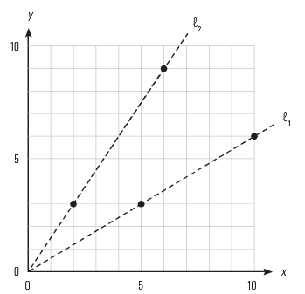 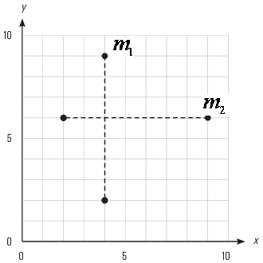

1. Complete the following with the teacher:

Using a ruler and a sharp pencil for precision, draw:

1. a solid line that passes through point A and has a slope of 
2. a dotted line that passes through point A and has a slope of 

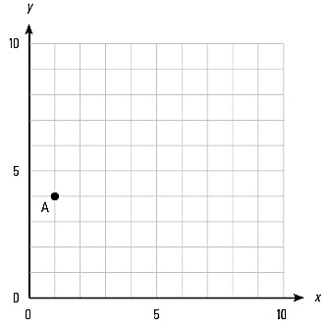

1. Morgan is starting to practise for a marathon.
2. If she walked 3 km in 30 minutes, what is her average rate in km/h?
3. Which is the independent variable?
4. If she does not change her pace, how long will it take her to walk a 36-km marathon?
5. Taylor is reading a book at a rate of 0.6 pages/minute.
6. How long will it take him to read the entire 321-page novel?
7. After 2 hours, how many pages will he have read?
8. A line on a graph has the following points. Plot the points and then calculate the slope of each line:

|  |  |
| --- | --- |
| a. (12, 3) and (16, 5) | b. (150, 3) and (25, 6) |
| Macintosh HD:Users:beckysulek:Desktop:Screen shot 2012-02-25 at 3.55.39 PM.png | Macintosh HD:Users:beckysulek:Desktop:Screen shot 2012-02-25 at 3.55.39 PM.png |

**DAY 8** *Water Slide Assignment , Getting Started*

Complete the table below to ensure you know how to read each point as well as find the slope, distance, angle and grade of each section.

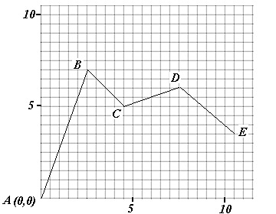

***scale:*** *1 square = 0.5 m on this diagram! (Your graph paper will be 1 square = 1 m.)*

**Coordinates:** A( , ) B( , ) C( , ) D( , ) E( , )

|  |  |  |  |  |  |
| --- | --- | --- | --- | --- | --- |
| Section | Distance | Slope | Tan of Angle Formed with Horizontal | Angle Formed  with the Horizontal | Grade (%) |
| AB |  |  |  |  |  |
| BC |  |  |  |  |  |

**WATER SLIDE Assignment**

You will design a water slide similar to the example above. You will design one ride. Think of a theme for the park and names for some of the rides. Your ride must have a **minimum of 4 sections**.

THE SCALE FOR YOUR OWN WATERSLIDE IS 1 SQUARE = 1 METER

**Check List**

Your waterslide park must include the following items:

1. The coordinates of the end points of each section of your ride

2. The distance of each section. d = 

3. The slope of each section. m = 

4. Angle formed with the horizontal 

5. Grade of the incline as a percent

6. Water park theme, name of slide, ruler and pencil used, neat work...

**Note: show your calculations for slope and distance**

**WATER SLIDE PROJECT**

**WATER PARK THEME:**

**RIDE NAME:**



|  |  |  |  |  |  |
| --- | --- | --- | --- | --- | --- |
| Section | Distance | Slope | Tan of Angle Formed with Horizontal | Angle Formed  with the Horizontal | Grade (%) |
|  |  |  |  |  |  |
|  |  |  |  |  |  |
|  |  |  |  |  |  |
|  |  |  |  |  |  |

**Note: You must show your all calculations for full marks!**

**DAY 9** *Chapter Review*

1. Calculate the slope of a ramp rising to a deck that is 1.8 m high and starts a horizontal distance of 4.5 m from the deck.
2. On a set of stairs, the slope of the railing is $\frac{2}{3}$. How much higher will the railing be a horizontal distance of 250 cm from the base?
3. A waterslide has an angle of elevation of 20**°**. What is the rise for a run of 2.6 m?
4. Garry is making a temporary ramp from the ground to the top of his patio so that he can roll a cart up it to move furniture in. The surface of the patio is 3 feet 9 inches above the ground and Garry wants the ramp to have a slope of no more than 0.375.
5. What is the shortest horizontal distance he can have from the base of the patio to the base of the ramp?
6. What is the shortest length the surface of the ramp can be?
7. What will be the angle of elevation of the ramp?
8. Shandra has a greenhouse in her backyard. The pitch of the roof is 4:12.
9. What is the slope of the roof?
10. What is the angle of elevation?
11. One section of the Crowsnest Highway has a 6% grade. What will be the vertical change for a horizontal change of 15 km?
12. How long will a section of railroad track be if it rises 6.8 metres for a run of 125.9 metres? What is the percent grade of the road?
13. If the pitch of a roof is 2:5, how much will it rise for a span of 3.5 m?



1. Rebecca earns $15.00 per hour.
2. Draw a graph of her earnings per hour.
3. What is the slope of the graph?

What does it represent?

1. How much will Rebecca have

earned after 8 hours?