Name:
Partner:

Research Assignment: Errors in Meiosis and Genetic Disorders
An image of the chromosomes in a human body cell is shown below. This is called a karyotype. It shows the 46 chromosomes organized into 23 pairs. One pair is the sex chromosomes, which determine the biological gender of the individual. XX chromosomes indicate a female karyotype and XY chromosomes indicate a male karyotype.
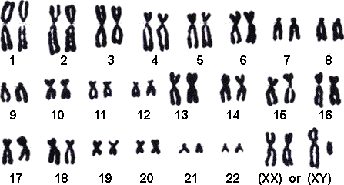

During meiosis, errors can occur. Many of these errors result in gametes that do not survive. However, some gametes do survive. If they are fertilized, they will still produce a zygote. Since every cell in an offspring is produced from the one zygote cell, all of the cells in the offspring will contain the error.
For example, an error that can occur in humans is a zygote having 3 copies of chromosome 21. This zygote develops into a person with down syndrome.
Activity
With a partner, you will do research on one genetic disorder that results in a change in chromosome number. You may choose any genetic disorder you like, but here is a list of genetic disorders to get you started:
Cystic Fibrosis | Sickle cell anemia | Huntington's disease | Hemophilia
Turner Syndrome | Marfan Syndrome | Duchenne Muscular Dystrophy | Down Syndrome

Questions

1) What is the error and how does the error occur?

2) What are the symptoms that a person who has the disorder experience?

3) What treatments are available?

4) How does the disorder affect a person’s lifestyle and the lives of their family members?

5) Come up with a question you have about this particular genetic disorder and determine the answer. If you can’t come up with the answer, how else might you determine the answer?

