**Energy:**

Name: ______________________

Date: _______________________

Block: _______

Lesson 5 – Conservation of Energy



Conservation of Energy: __________________________________________________



______________________________________________________________________



Total Energy = Kinetic Energy + Potential Energy



Ex. An object has 13 J of kinetic energy and 20 J of potential energy. What is the object’s total energy at this time?



Ex. An object has a total energy of 230 J and a potential energy of 150 J. What is its kinetic energy at this time?



Ex. Luc drops a 5 kg book, when it is 5 m from the ground the book has a speed of



5 m/s. What is the total energy of the book at this point?



**Where does it have kinetic or potential?**



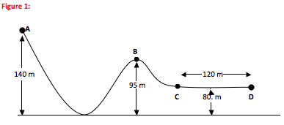



**D**

**B**

**C**

The 2kg ball starts at rest. What is the potential and kinetic energy at each point?



A:



B:



C:



D:

