Your Genes
Trait | Allele | Your Phenotype | Your Possible Genotype
1. Shape of face | Oval (O) dominant, square (o) recessive
2. Cleft in chin | No cleft (C) dominant, cleft (c) recessive
3. Hair curl | Curly (W): homozygous  Wavy: heterozygous  Straight (w): homozygous
4. Hairline | Widow peak (P) dominant, straight hairline (p) recessive
5. Eyebrow shape | Separated (U) dominant, joined (u) recessive
6. Eyelash length | Long (L) dominant, short (l) recessive
7. Dimples | Dimples (D) dominant, no dimples (d) recessive
8. Earlobes | Free lobe (A) dominant, attached (a) recessive
9. Eye shape | Almond (R) dominant, round (r) recessive
10. Eye colour | Brown (B) dominant, blue or green (b) recessive
10. Freckles | Freckles (F) dominant, no freckles (f) recessive
11. Tongue rolling | Roller (T) dominant, nonroller (t) recessive
12. Interlaced fingers | Left thumb over right (Q) dominant, right over left (q) recessive

Celebrity Match Making
Create Punnett squares for eye colour, hair curl, freckles and face shape with 3 different celebrity couples. What might their imaginary babies look like?
Celebrities (Or pick your own)
Female |  | Male
Kim Kardashian  Brown Eyes  Straight Hair  No freckles  Oval Face | 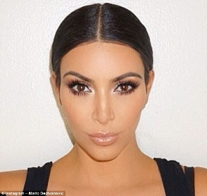 | Drake  Brown Eyes  Curly Hair  No freckles  Oval Face | 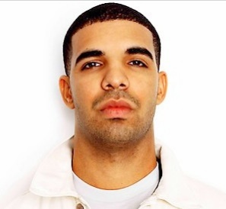
Taylor Swift  Blue Eyes  Curly Hair  No freckles  Oval Face |  | Ryan Reynolds  Brown Eyes  Straight Hair  No freckles  Square Face | 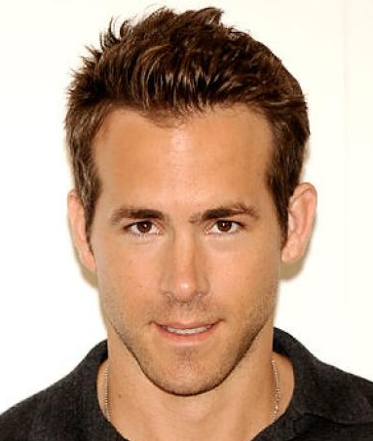
Beyoncé  Brown Eyes  Straight Hair  No freckles  Oval Face | 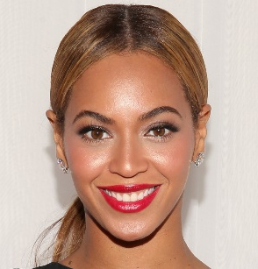 | Justin Bieber  Brown Eyes  Straight Hair  No freckles  Square Face | 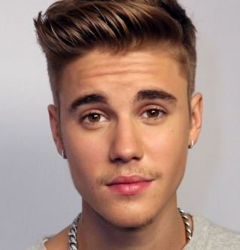
Jennifer Lawrence  Blue Eyes  Curly Hair  Freckles  Square Face |  | Harry Styles  Blue Eyes  Curly Hair  No freckles  Square Face | 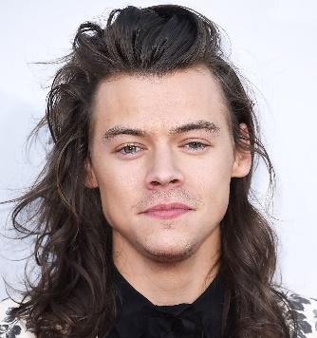
Katie Perry  Blue Eyes  Wavy Hair  No freckles  Oval Face | 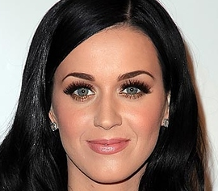 | Zayn Malik  Brown Eyes  Straight Hair  No freckles  Square Face

Dominance
Eye Colour - Brown (B) dominant, blue or green (b) recessive
Hair Curl - Curly (W): homozygous, Wavy: heterozygous, Straight (w): homozygous
Freckles - Freckles (F) dominant, no freckles (f) recessive
Face Shape - Oval (O) dominant, square (o) recessive

First write down the celebrity’s possible genotype (BB, Bb or bb)

1) Couple ________________ & ________________ Baby’s Name: __________________
Eye Colour

Hair Curl

Freckles

Face Shape

Describe the most likely baby.

2) Couple __________________ & __________________ Baby’s Name: __________________
Eye Colour

Hair Curl

Freckles

Face Shape

Describe the most likely baby.

3) Couple __________________ & __________________ Baby’s Name: __________________
Eye Colour

Hair Curl

Freckles

Face Shape

Describe the most likely baby.

